TASK 1 : Guided Activity, Student profile card
import Foundation
//Step 1: Create Constants
let studentName = "Asha"
let rollNumber: Int = 2301

// Step 2: Create variables and a Boolean constant
var semester = 5
var cgpa: Double = 8.25
let isHosteller = true

// Step 3: Print student details
print("Name: \(studentName), Roll: \(rollNumber), Semester: \(semester)")

// Step 4: Update semester and CGPA
semester += 1
cgpa = 8.5
print("Semester: \(semester), CGPA: \(cgpa)")

// Step 6: Print the type of each value
print(type(of: studentName))
print(type(of: rollNumber))
print(type(of: semester))
print(type(of: cgpa))
print(type(of: isHosteller))

OUTPUT:
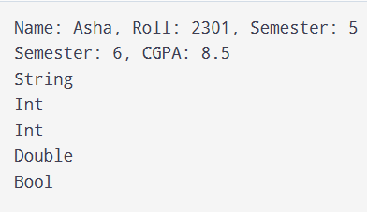
Task 2: Practice Task, Temperature converter
import Foundation
let factor = 9.0 / 5.0
var celsius: Double = 25.0

// Convert temperature
func convert() {
let f = celsius * factor + 32
let k = celsius + 273.15

print("Fahrenheit: \(String(format: "%.1f", f))")
print("Kelvin: \(String(format: "%.1f", k))")
}

// First conversion
convert()

// Change temperature
celsius = 100
convert()

OUTPUT:
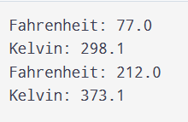

Task 3: Debug Task, Fix the compile errors

var price = 250.0 ----------------------> Instead of let , used var
var quantity: Int = 3
let taxRate = 0.18
price = 300
var title = "Order"
String cannot store an Int
title = "42"
let subtotal = price * Double(quantity) ---------------------> convert Int values to Double
let total = subtotal * (1 + taxRate)
print(total)

OUTPUT:
162.0

